Health Commissioners Monthly Report for July/ August 2015
Submitted by Trish Factor

Staff Meetings

Again, summer staff meetings have allowed our department to work through various aspects of daily operations of the department in order to make it more efficient and effective. We are also working on aligning documentation methods in order to better prepare ourselves for Accreditation as well as our own Strategic Planning (including more accurate cost analysis’).

Funding

Contracts with 2 school districts were finalized at last month’s BOH meeting. Saint Joseph Catholic School- Galion has now signed (delayed due to their new staffing) and this contract is being presented today.

Biennial Budget (HB 64)

A comparison document for the budget bill has been provided (under New Business). If you have any questions, please feel free to send them to Trish (trish.factor@odh.ohio.gov) and we can discuss at the September meeting.

Building

I met with John Swain to go over the renovation needs for the department and he approved all of them that we discussed. Additional quotes for office space projects are being sought and should all be in before the end of August. Not all renovations may be done at the same time; we may need to take it step by step. However, we are prioritizing the projects based on the needs of the clients we serve.

Network of Care

Based on the network of Care training the Trish and Ashley had previously attended; Trish was able to do a conference call with the Vice President of the site. The Galion City Health Departments data site is now up and running and we have the ability to go in and add various things (i.e. annual reports, CHA/ CHIP, announcements, etc.) residents can also input their medical history, medication lists, etc on their own secure PHR page (Personal Health Record). To take a look at the site and provide feedback go to http://galion.oh.networkofcare.org/ph/ . please feel free to let Trish know if there is anything you would like to see added; play around with it a little bit. Once we have it set up as we want it, we will link it to our webpage and do a press release about the uses of the data and the PHR. *This was a free project!

Trainings/ Workforce Development

The Workforce Development Plan is still in progress; I hope to have a draft to share soon. Staff will be able to follow and will be held accountable for training requirements incorporated within. This plan will also include the training plans for newly hired employees. *All staff has access to online training portals

APIC Training (Intensive EPI 101 & 102)
Trish will be attending this course 8/10-14/15. A representative from each department in the Central Planning Region is attending. The cost is being covered through the Regional Ebola Supplemental Funding, any other cost (i.e. travel & meals) are covered through our local Ebola funding.
This course compresses infection prevention fundamentals from the EPI® 101 and 102 classes into a 5-day interactive intensive learning experience. Board certified (CIC®) subject matter experts update course content throughout the year, so we’ll learn the newest terminology and current definitions and hear about the regulatory issues of importance today and in the future.
This course introduces the various roles and responsibilities of the infection preventionist. Areas of emphasis include how to prepare surveillance and risk assessment plans, regulatory compliance, preventing transmission of infectious diseases, how to handle employee exposures and evidence-based interventions to prevent or reduce risk. A certified and experienced faculty team presents the course with a hands-on training approach.
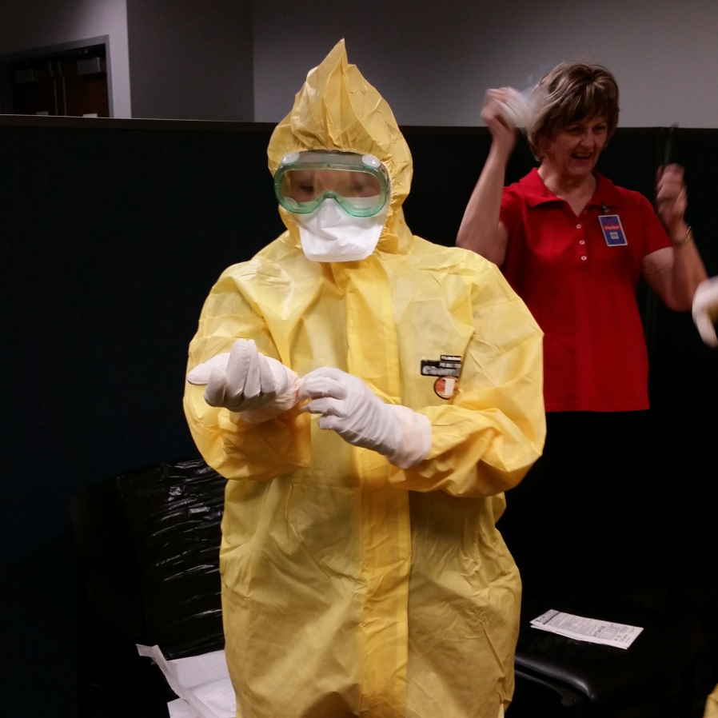
Personal Protective Measures for Biological Events Course
Trish and Ashley will be attending this course 7/15/15. This course is designed to ensure that they have the information and resources needed to properly prepare for and respond to infectious disease outbreaks such as Ebola, and to collaborate with the healthcare sector through participation in regional healthcare coalitions.
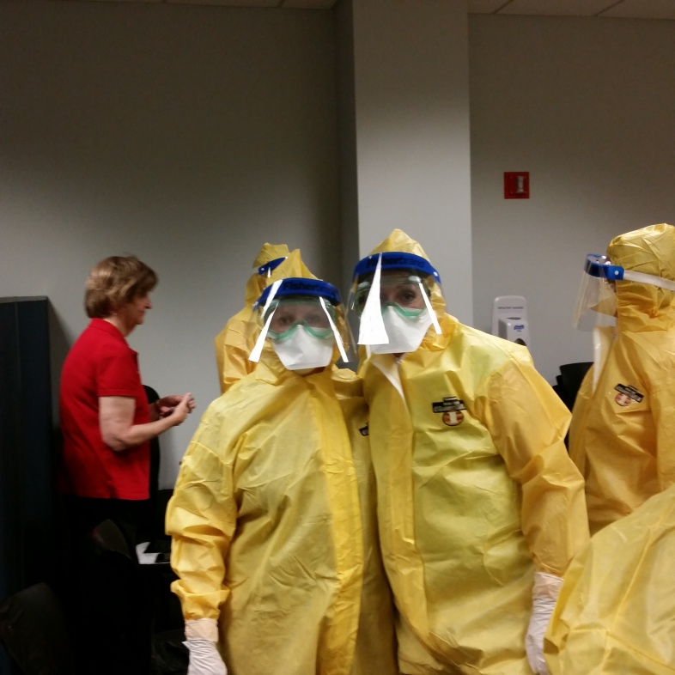
ODH is coordinating with the Federal Emergency Management Agency’s (FEMA) Center for Domestic Preparedness (CDP) to provide the course. This course will provide an overview of personal protective equipment (PPE), and includes an experimental learning activity (ELA) practicing donning and doffing PPE Level C. Additionally; there is a review of the different types of decontamination and an ELA practicing technical decontamination.
Accreditation Learning Community
Trish and Stephanie attended the Accreditation Coordinators learning Community on 7/17/15. Much was learned and additional points of contact for reference questions were made.

Continuous Quality Improvement

The Quality Improvement Plan for the department is still going good. Again, this is required for Accreditation. Quality Improvement projects have already begun to take shape based on internal needs assessments. Additions and/or revisions to the plan will continue to be made and a draft plan to share with the BOH should be completed soon.

Personnel Policies and Procedures

Additional updates and/or revisions are being considered based on knowledge gained through research. Trish continues to work with the City Law Director in order to clear up the status of City Health Department Employees; this is highly important in terms of numerous aspects of personnel policies and overall administration of the department. The legal opinions and aspects have put this process in a holding pattern in some regards.

Outreach

Safety Town
The Galion City Health Department presented at the “come back” of Galion’s Safety Town. Buckle Bear (Theresa & Ashley) presented car seat safety on Monday 8/3/15 and Kara presented sessions on personal and hand hygiene using Glow Germ on Wednesday 8/5/15.
The health department provided various handouts to both kids and parents. Parents were provided with immunization information to help ensure that all necessary vaccinations for school admission have been obtained. It was a great opportunity to reach out to the youth of our jurisdiction and get them started on the road to a safe and healthy lifestyle; this program was geared toward the incoming Kindergarteners. There was media coverage of this event.
Galion City Police, Fire, and Health
Trish attended the 7/30/15 meeting and provided updates on our road to Accreditation and some of the changes occurring within our department. I am hoping that I will be able to continue to provide updates at these meetings as our department is continually changing.
Community Counseling (Mental Health)
With the MOU having been sign last month, we are able to support mental health outreach by Community Counseling within the Health Department to allow for counseling sessions to take place locally. Again, there was been great feedback and an obvious need for these services to be provided right here in Galion. This continues to allow our department to aid in the outreach of mental health services.

