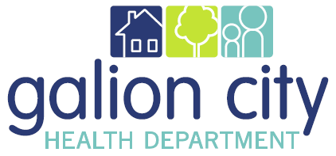
2016 SWOT Analysis
A SWOT Analysis is a quick way of examining your organization by looking at the strengths and weaknesses in relation to the opportunities and threats. By creating a SWOT Analysis, you can see all the important factors affecting the department together in one place.
Strengths | Weaknesses
Strengths refer to what the GCHD does well.  What do we want to build on?  Questions to ask:  - What do you do well?  - What differentiates us from competitors?  - Why do clients come here? | Weaknesses refer to any limitations the GCHD faces in developing or implementing a strategy.  What do you need to shore up?  Questions to ask:  - Where do you lack resources?  - What can you do better?  - Where are you losing money?  - In what areas do your competitors have an edge?
Opportunities | Threats (Challenges)
Opportunities are situations that exist but must be acted on if the GCHD is to benefit from them.  What do you want to capitalize on?  Questions to ask:  - What new needs of clients could we meet?  - What economic trends could benefit us?  - What are the emerging political and social opportunities?  - What niches have your competitors missed? | Threats refer to external conditions or carriers that may prevent GCHD from meeting its objectives.  What do you need to mitigate?  Questions to ask:  - What are the negative economic trends?  - What are the negative political and social trends?  - Where are competitors about to bite you?  - Where are you vulnerable?

