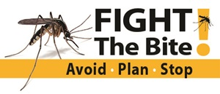
Ohio Mosquito-borne Disease Surveillance
August 27, 2018
The Ohio Department of Health (ODH) Zoonotic Disease Program, in partnership with ODH Laboratory, local public health partners and sanitary district partners, collects and tests mosquitoes from many communities in Ohio as part of statewide mosquito-borne disease surveillance. This surveillance also includes monitoring for human and veterinary cases as well.
Collections of mosquitoes are identified and tested at ODH Laboratory, and the results are shared with our partners who use the information to help guide public health interventions. We will continue monitoring for mosquito infections throughout the summer and will report positive findings and summary statistics on this website. The website will be updated each Monday at noon, so check back periodically for updated information. Click here for detailed information on mosquito surveillance.
Ohio Mosquito-borne Disease 2018 Numbers At-A-Glance
As of August 27, 2018 12:00 pm
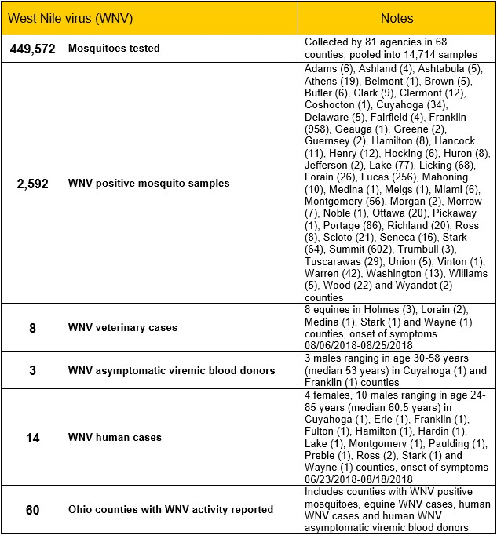
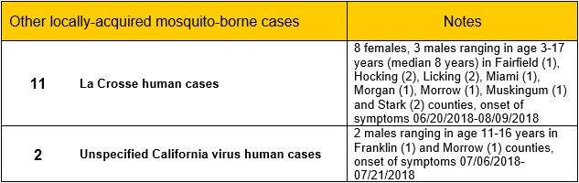
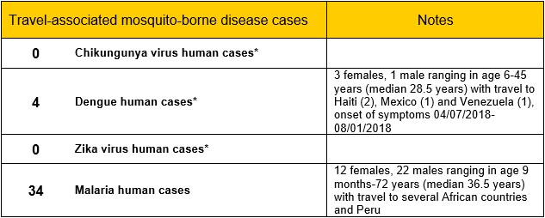
* Ohioans traveling to areas where local transmission is occurring should be aware of the ongoing situation and make every effort to avoid mosquito bites. Additional information can be found from the Centers for Disease Control and Prevention (CDC)'s Travelers' Health and Pan-American Health Organization websites.

Now is a good time to start or increase your community and public education efforts focusing on personal protection and source reduction to include these points:
AVOID mosquitoes and mosquito bites
- Use insect repellents when you go outdoors or wear clothing treated with permethrin or another EPA-registered repellent for extra protection.
- Take care during peak mosquito biting hours, perhaps avoiding outdoor activity and wearing appropriate clothing.
PLAN ahead for mosquitoes while traveling
- Check travel notices for mosquito-borne and other disease transmission updates. Visit the Centers for Disease Control and Prevention (CDC)'s Travelers' Health website to search for the latest health notices for the country you're traveling to.
- Speak to your healthcare provider about your travel plans and measures you can take to reduce your risk of mosquito-borne diseases.
- Pack appropriately to protect yourself from mosquitoes by bringing insect repellents, appropriate clothing and mosquito netting if sleeping outdoors or in unscreened structures.
STOP mosquitoes from breeding in and around your home
- Reduce the number of mosquitoes around your home by discarding and emptying water-holding containers and using products containing Bacillus thuringiensis israelensis (Bti), available at many garden and home improvement stores, to control mosquito larvae in containers that are too large to empty.
- Keep mosquitoes outside by installing or repairing screens on windows and doors.
Taking these steps will help protect against mosquito-borne La Crosse, West Nile and Zika viruses.

Additional resources
Centers for Disease Control and Prevention: Arboviral Disease Maps

Contact information
Ohio Department of Health
Bureau of Infectious Diseases
Zoonotic Disease Program
246 N. High St.
Columbus, OH 43215
Phone: (614) 752-1029
Fax: (614) 564-2437
E-mail: Zoonoses@odh.ohio.gov

