Hepatitis A Statewide Community Outbreak
The Ohio Department of Health (ODH) and affected local health departments are investigating an increased number of hepatitis A cases in Ohio. ODH has declared a statewide community outbreak of hepatitis A after observing an increase in cases linked to certain risk factors since the beginning of 2018. Outbreaks of hepatitis A are occurring in several states across the U.S., including neighboring states of Indiana, Kentucky, Michigan and West Virginia.
Hepatitis A is a vaccine-preventable liver disease that usually spreads when a person ingests fecal matter - even in microscopic amounts - from contact with objects, food or drinks contaminated by the stool of an infected person. Hepatitis A can also be spread from close personal contact with an infected person, such as through sex.
People at increased risk for hepatitis A in this outbreak include:
- People with direct contact with individuals infected with the virus
- Men who have sex with men
- People who use street drugs whether they are injected or not
- People who are incarcerated
- People experiencing homelessness
- People who have traveled to other areas of the U.S. currently experiencing outbreaks
Symptoms of hepatitis A include fatigue, low appetite, stomach pain, nausea, clay-colored stools and jaundice. People with hepatitis A can experience mild illness lasting a few weeks to severe illness lasting several months.
People who believe that they are at high risk for hepatitis A infection should contact their healthcare provider or local health department for information about vaccination. People who know that they have been exposed to someone with hepatitis A should contact their healthcare provider or local health department to discuss post-exposure vaccination options. Individuals who experience symptoms of hepatitis A should contact their healthcare provider.

Outbreak Case Statistics
(Information will updated each Monday by 2:00 PM)
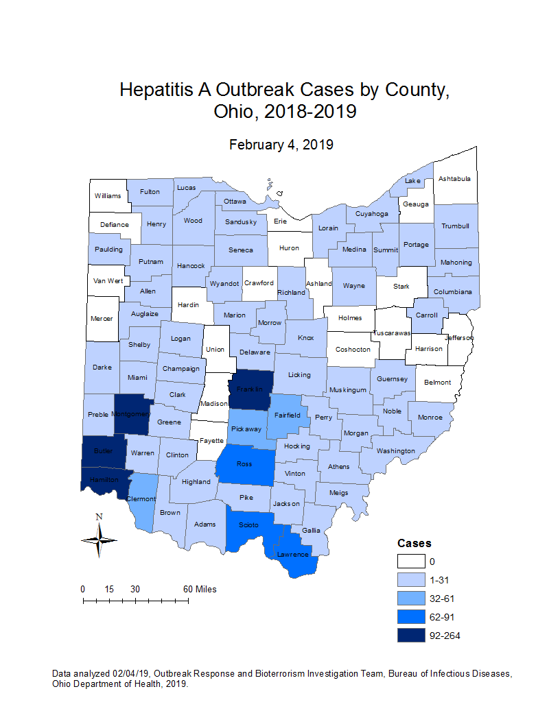
Ohio Hepatitis A Outbreak Cases by County (February 4, 2019):
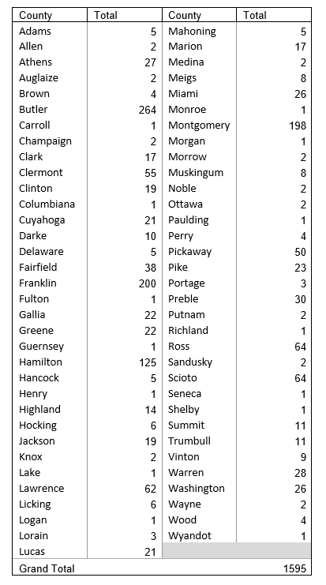

Hepatitis A Outbreak Summary (December 31, 2018):
- Number of cases: 1595
- Illness onset range: 01/05/2018 – 01/31/2019
- Age range: 2-81 years
- Gender: 60% male
- Number of hospitalizations: 1001 (63%)
- Number of deaths: 5
- Number of counties with cases: 67 (76%)
Ohio Hepatitis A Outbreak Case Definition:
CLINICAL CRITERIA
An acute illness with a discrete onset since January 1, 2018 of any sign or symptom consistent with acute viral hepatitis (e.g., fever, headache, malaise, anorexia, nausea, vomiting, diarrhea and abdominal pain), and either
- Jaundice, OR
- Elevated aspartate aminotransferase (AST) or alanine aminotransferase (ALT) levels (>200 IU/L)
LABORATORY CRITERIA
- Immunoglobulin M (IgM) antibody to hepatitis A virus (anti-HAV) positive, OR
- Nucleic acid amplification test (NAAT) for hepatitis A virus RNA positive (including PCR or genotype testing)
CONFIRMED HEPATITIS A OUTBREAK CASE
- A case with a specimen that matches the circulating outbreak strain (genotype 1B), OR
- A case that meets the clinical and laboratory criteria, OR
- A case that meets the clinical criteria and occurs in a person who has an epidemiologic link with a person who has laboratory-confirmed hepatitis A (i.e., household contact, drug partner or sexual contact with an infected person during the 15-50 days before the onset of symptoms)
EXCLUSIONS
A case will be excluded if any of the following conditions apply:
- In the absence of known risk factors (illicit drug use, men who have sex with men, homelessness, incarceration or domestic travel to an area with a known outbreak), any illness that occurs in a patient who reports travel to a country or U.S. territory with endemic hepatitis A during the 15-50 days before symptom onset, OR
- Specimen is identified as any genotype other than 1B, OR
- Specimen collected within four weeks of symptom onset is negative for HAV RNA, OR
- A more likely clinical explanation is available to account for clinical symptoms and laboratory findings
For more information, please call the Ohio Department of Health Bureau of Infectious Diseases at (614) 995-5599.
https://odh.ohio.gov/wps/portal/gov/odh/know-our-programs/outbreak-response-bioterrorism-investigation-team/news/newsevent1

