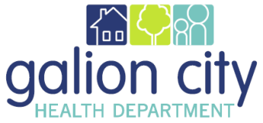
Galion City Board of Health
Health Commissioners Monthly Report for May 2021

Fiscal/Funding

Olivia is doing her best managing grants, purchase orders, etc. The problem still exists of receiving funds that were not budgeted for or being able to carry over funds where a grant timeframe runs for 12 months, not necessarily our fiscal year.

Emergency Preparedness

Covid and Covid funding reports are still consuming time even though the demand is not high. Some of the funding is deliverable-based with deadlines. Emily and Lynn are going out into the community at targeted SVI areas to offer the vaccine. We have also asked the Galion Fire Department to hand out cards to homebound individuals they may visit, explaining that a nurse will come to them if the vaccine is wanted.

Communicable Disease

 | Confirmed Communicable Disease by Type
 | Sexually Transmitted Infections | 4
 | Vaccine Preventable Illness | 0
 | Bloodborne Pathogens | 0
 | Enteric Illnesses | 2
 | Other Illnesses | 10
 | Vectorborne Illnesses | 0
 | Total | 16

Staff

Although we have been very busy trying to pick up the pieces that were left undone, I do believe the staff morale is much better than it has been for the past few years. We are working together well.

Accreditation

Staff is continuing to work on accreditation pre-site review questions that have been proposed by PHAB. Our goal is to get all of that completed in June.

