Outreach Report
Third Friday in Galion
June 16, 2021
Division:
Environmental Health
Mosquito Control
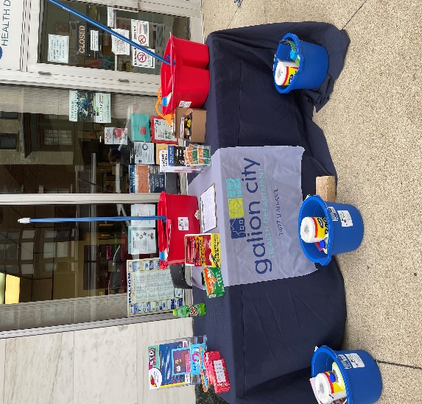

Participating Staff:
Andrea Barnes, R.S. Director of Environmental Health
Olivia Roston, Business Officer
Jenny Jordan, CMA

Anticipated Outcome: To provide Healthy Homes Information, specifically lead poisoning prevention supplies to families with children under the age of 6, living in older, pre-1978 homes. To give mosquito dunks to Galion residents for areas of standing water as well as education on mosquito/ticks and prevention of disease. To provide condoms to individuals to practice safe sex. The Galion City Health Department also let the community know that we still have the Covid-19 vaccination for anyone wanting or needing it.

Description of event:
Location: Galion City Health Department
Audience: Galion and area residents
# of Community Members Impacted: approximately 13 families/individuals
Sponsor: Galion Chamber of Commerce & Galion Community Theatre

Outcomes of event: During the event 13 families were given Lead Poisoning Prevention supplies and information. Approximately 10 families were given mosquito dunks. Approximately 3 individuals were given condoms. One bat house was also given to a Galion resident.

Andrea Barnes, R.S.
Interim Health Commissioner

