**Outreach Report**

**Third Friday in Galion**

**August 20, 2021**

**Division:**

Environmental Health

Sexual Health Clinic

Admin/Nursing

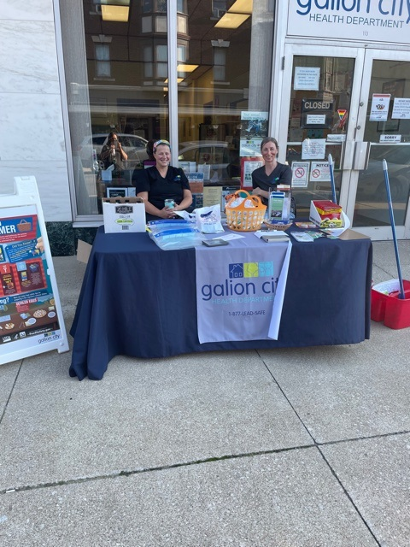

**Participating Staff:**

Andrea Barnes, REHS Interim Health Commissioner

Olivia Roston, Admin, Vital Statistics Registrar

Sarah Miley, MSN, APRN, WHNP-BC, Sexual Health Clinician

**Anticipated Outcome:** To provide Healthy Homes Information, specifically lead poisoning prevention supplies to families with children under the age of 6, living in older, pre-1978 homes. To give mosquito dunks to Galion residents for areas of standing water as well as education on mosquito/ticks and prevention of disease. To promote our sexual health clinic and provide condoms to individuals to practice safe sex. Provide Covid-19 vaccination for anyone wanting or needing it, and supply the citizens with hygiene packets (masks, gloves, & hand sanitizer).

**Description of event:**

**Location:** Galion City Health Department

**Audience:** Galion and area residents

**# of Community Members Impacted:** approximately 18 families/individuals

**Sponsor:** Galion-Crestline Chamber of Commerce

**Outcomes of event:** During the event 18 families were given Lead Poisoning Prevention supplies and information. Approximately 13 families were given mosquito dunks. Approximately 5 individuals were given condoms. Two families answered our open-ended question survey about lead poisoning prevention and cleaning.

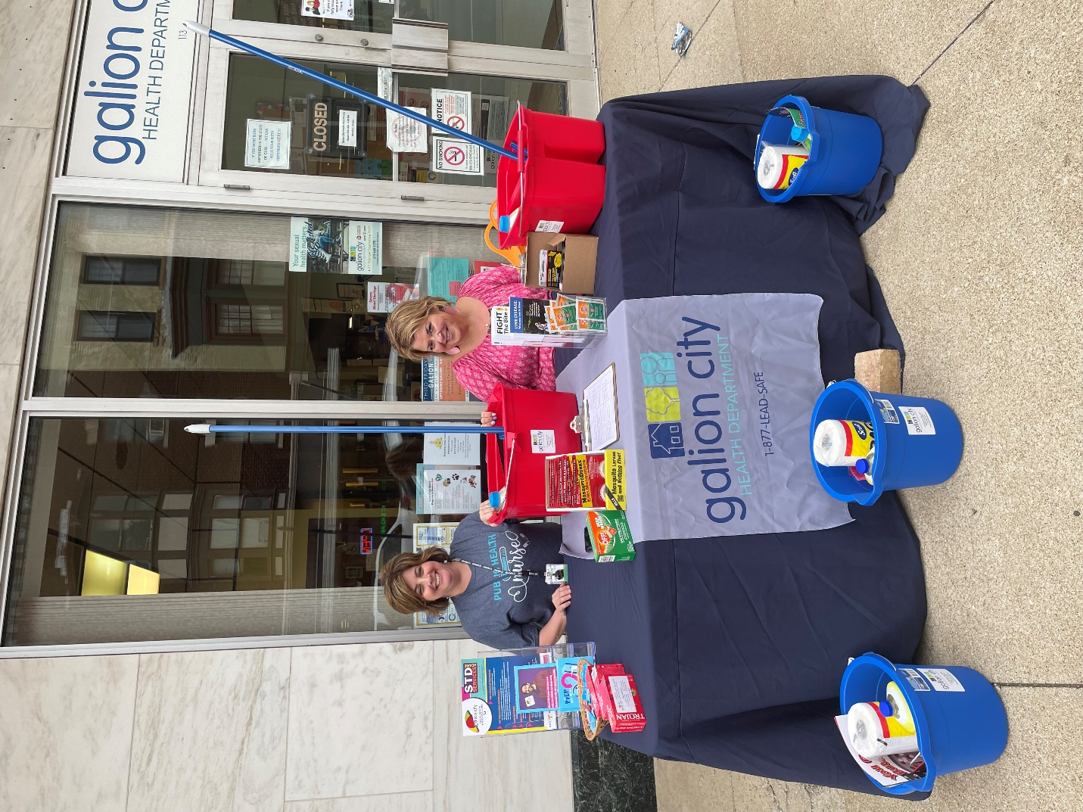

Monica Light, RN and Tina Nichols, DIS

Respectfully submitted,

Andrea Barnes, RS