Outreach Report
GAY PRIDE
8/7/2021
Division:
STI/HIV Prevention
Participating Staff:
Sarah Miley, APRN
Tina Nichols, Disease Intervention Specialist

Anticipated Outcome: To make community aware of Galion City Health Department Services for Sexual Health Clinic, PrEP/HIV Prevention, testing, and education.

Description of event: GCHD attended GAY PRIDE Event in Mansfield, OH. We were sponsors, and participated in the parade, had a booth, and provided condoms and education.
Location: Mansfield/Richland County
Audience: 500+ Individuals
# of Community Members Impacted: We spoke to over 150 individuals, handed out posters, condoms, pens, candy and PrEP information to the public. At the end of the day, we loaded up the local LGBTQ Bar with the excess condoms, posters, and materials.
Sponsor: GCHD

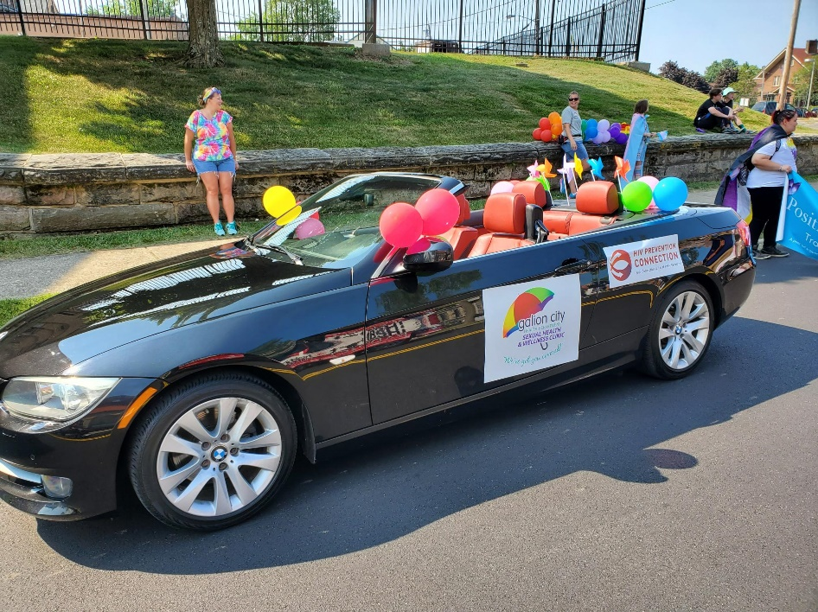
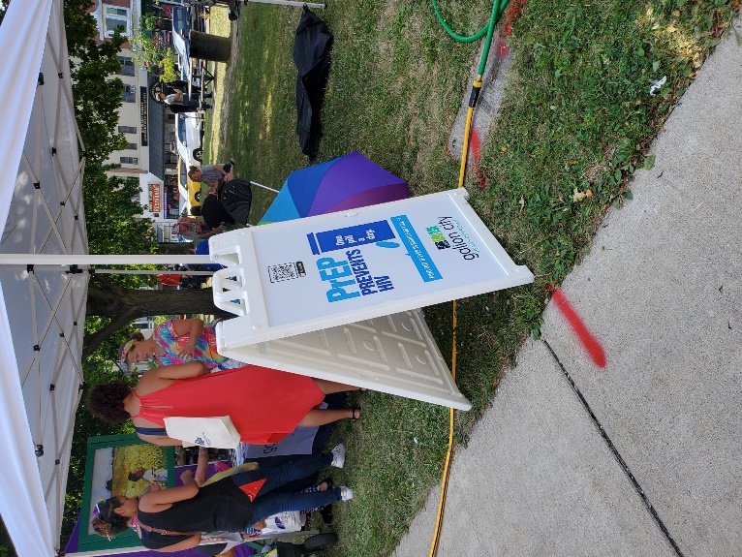

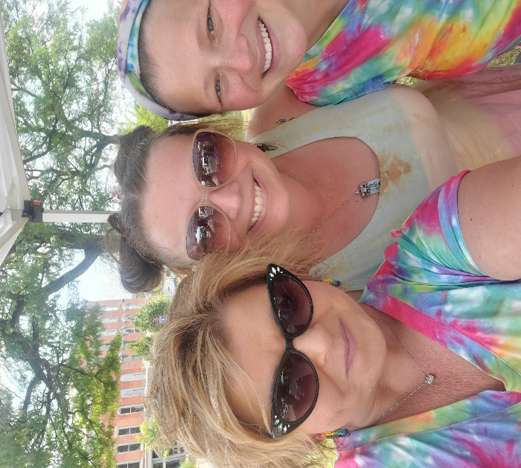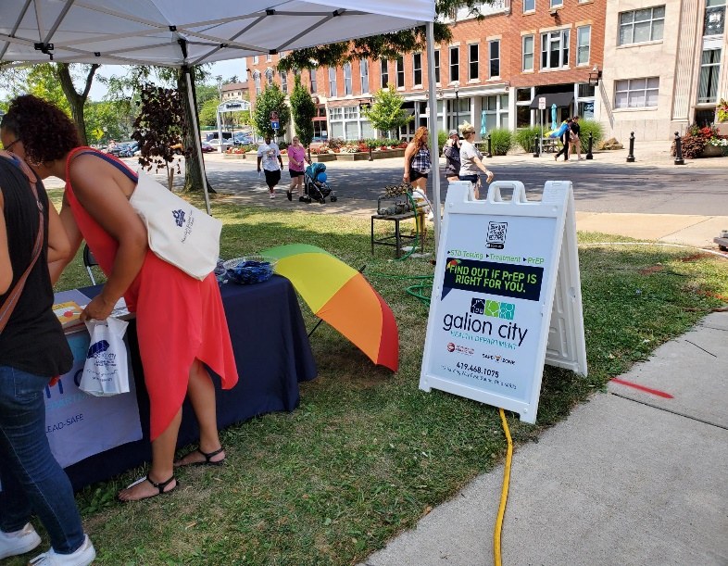

Outcomes of event: Richland County is one of the 9 counties we serve on HIV Prevention Grant. We had many community members, and event goers, make a comment about the good work we are doing in the community. We had a productive day and met many people we could refer for services.

In what ways can outreach be improved? Our day couldn’t have been better, we were well received, and felt good about our presence there for the community!

