Come Home to Galion

12/4/2021
Outreach Report
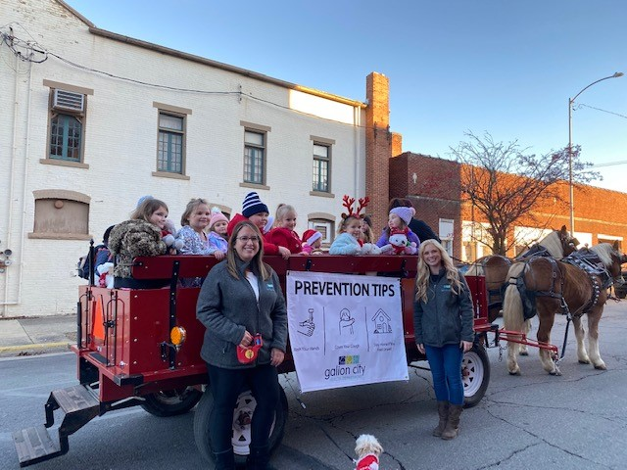

Division:
All divisions

Participating Staff:
Andrea Barnes, Interim Health Commissioner, Environmental Director
Emily Miller, Director of Nursing
Tina Nichols, Disease Intervention Specialist
Sara Miley, Sexual Health Nurse Practitioner

Anticipated Outcome: Provide advertisement and community involvement to produce a more desirable reputation for the Galion City Health Department.

Description of event: Every year Galion City along with the Chamber of Commerce puts on the Come Home to Galion Christmas kick off celebration. Many activities take place on this day including a parade. Every year the Galion City Health Department conducts a coloring contest for students between preschool and 2nd grade at the Galion City Schools and at Galion St. Joseph School. Two winners are selected from each grade and are invited to ride on a horse drawn carriage in the parade. Each year a give away for the coloring contest winners is handed out. This year, Kara Kimerline, PRN Public Health Nurse for the Galion City Health Department donated stuffed animals for the winners. During this year’s celebration the Galion City Health Department along with many other active businesses and community members participated in a parade. The Galion City Health Department staff meet up with the coloring contest winners at Heise Park, next to the tennis courts at 3:30pm. At that time, the winners were awarded their stuffed animal. The parade took place down Harding Way from 4:15-4:45. Ten children and their families participated in the parade and rode in the carriage.

Location: Galion City
Audience: Galion City Residents
# of Community Members Impacted: 10 children and their families rode in the carriage.
Sponsor: Chamber of Commerce

Outcomes of event: This is a fun event to participate in. It puts us in the public eye and allows for us to promote health in a fun and engaging way.

In what ways can outreach be improved?
- This outreach even takes place in December and can be very cold! It is important for staff who participate to dress warm.
- It would also be important to remind the children and their families that participate in the event to dress appropriately.
- If the parents choose not to ride in the carriage/walk with the parade, it is important that they provide a contact number at drop off to ensure the children are returned to their families at conclusion of the parade. Names should also be recorded for who is participating in the parade.
- For this event, the Galion City Health Department provides their own banners to display on the carriage. It is important for staff to ensure the banners are brought as well as zip ties to attach the banners to the carriage as well as a means to remove the banners.

