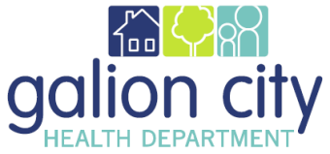
Galion City Board of Health
Health Commissioners Monthly Report for February 2022

Fiscal/Funding

Olivia is keeping on top of our budget. She is really doing a superb job with the grants, paying bills, and assisting with explaining when we need to ask for appropriations. We were able to complete a budget revision for the Workforce Development Grant as well.

Emergency Preparedness

GCHD is still offering both the COVID-19 Moderna & Pfizer two-dose vaccine plus boosters. The state still wants LHD’s to vaccinate our communities, promote the vaccine and boosters, and go to the people to get it done. The Pfizer is also being offered to the 5-17 year old population at all clinics. GCHD will continue to promote the availability of the vaccine for anyone who wants it. GCHD will purchase more Covid-19 incentive gift cards for anyone receiving their first dose of Covid-19 vaccine in March through the CN22 grant.

Staff

On February 25th, I was more than happy to welcome Jason McBride aboard to be our new health commissioner. We are looking forward to working with him to move our health department in the right direction.

Unfortunately, we have been so busy, we have not been able to have a staff meeting since December, but that will change once we become fully staffed.

Accreditation

PHAB has informed us that our site visit report is going to the accreditation committee on March 9, 2022 which is later that we were originally told but FINALLY. I have reviewed the site visit report and some of the comments and determined that we had 46 fully demonstrated measures, 36 largely demonstrated measures, 15 slightly demonstrated measures, and 3 that were not demonstrated. It is almost certain that we will be put on an action plan for a year like many LHD’s in Ohio did with the initial site visit.

