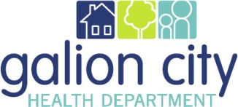

Galion City Board of Health
Environmental Division Monthly Report for February 2022

Food Safety

February is very much dragging into March for me as I had to help unexpectedly to complete 19 FSO inspections within the last 2 days of the month. In order for GCHD to be in compliance with the ORC as well as process several licenses for renewal through March 1st; definitely too much going on at one time for certain.

Public Health Nuisances

There were 4 nuisance complaints during the month of February. The complaints were solid waste and or scrap tire nuisance complaints. Also, correspondence was given to a few people on tenant landlord issues as well.

General Environmental Health

GCHD expects to hear news on the 2022 mosquito control grant in March. Funding and final reports will be completed in March and April for the 2021 mosquito control grant. Healthy homes buckets are still available to the public in Galion, focusing on residents living in homes built pre-1978 to do wet-cleaning to minimize lead dust hazards within the home.

Rabies

Galion received 1 dog bite in February of 2022. This dog bite is still awaiting compliance by the owner to obtain current rabies vaccination for the dog. The Annual survey by the Ohio Department of Health for animal bite reporting has been sent to our department and will be completed in March.

Respectfully submitted,

Andrea Barnes, REHS
Director of Environmental Health

