Outreach Report
Mobile Food Pantry Event
6/29/22, 3:00-4:00
Division:
Environmental

Participating Staff:
Jason McBride

Anticipated Outcome: To provide health education and free items to help protect against mosquitos.

Description of event: There are periodic mobile food pantry events where rows of cars line up and wait their turn to receive food. Vendors are allowed to talk with people in their cars while they are parked and waiting in line. I provided information on protecting against mosquitos, I gave away a box of mosquito boxes and two boxes of bug spray wipes.
Location: Galion High School
Audience: All interested community members
# of Community Members Impacted: Approximately 20 people received information in total. 11 people signed the optional form showing where they intended to use the mosquito dunks. A few more did not sign the form or received just the wipes or brochures.

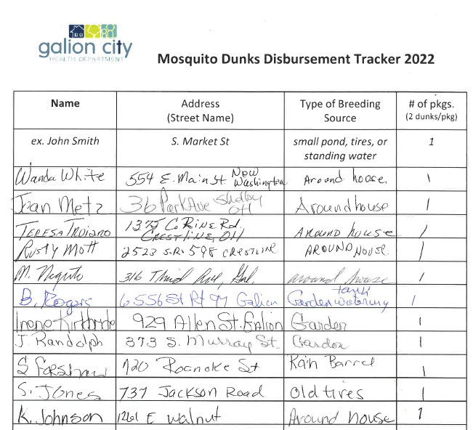

Outcomes of event: People were very appreciative of the free materials and giveaways.

In what ways can outreach be improved? This event is a more unusual outreach event because there is no table and chairs set up. I had shared this event with Tina in hopes that she can have another outreach event. She arrived but couldn’t stay because she needed a table and chairs. We will know for next time that this event is not a good fit unless she can sit behind a table with her materials.

