Outreach Report
WIC Baby Shower
August 4, 2022
Division:
Environmental and nursing

Participating Staff:
Jason McBride
Andy Barnes

Anticipated Outcome: To provide participants with information on child car seat safety, the child car seat program, and environmental health matters.

Description of event: Every year for the past 30 years or so, WIC hosts a community baby shower. The location changes each year. Participants were there from Bucyrus, Galion, Crestline, and other places. Participants were given questions to ask all the vendors, and many people chose to ask us if they can buy birth certificates from us.
Location: Avita Hospital
Audience: Pregnant mothers who are also WIC participants
# of Community Members Impacted: Approximately 30 participants stopped by our table.

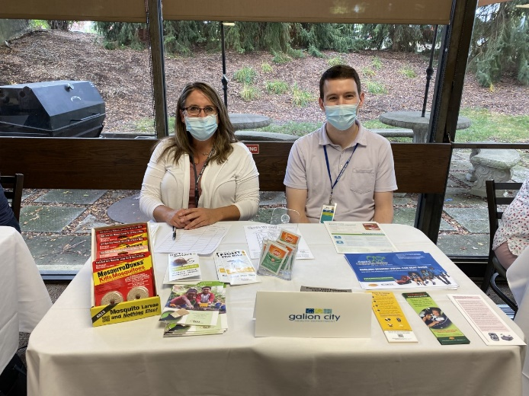

Outcomes of event: The cafeteria was full of participants and vendors. There were well over 100 people who participated in the event overall. In addition to most everyone receiving brochures and learning other information that we shared, one lucky participant was able to receive a free car seat, and another lucky participant was able to receive cleaning supplies. I consider this a successful event.

In what ways can outreach be improved? I can’t think of anything I would do to improve this event. It was well-organized and seemed meaningful to the participants.

