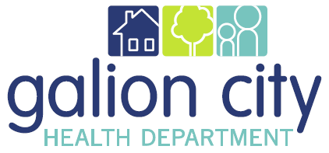
2022 Board of Health Meeting Dates
All meetings begin at 5:00 pm and are located at the Galion City Health Department, unless otherwise notified
January 11, 2022
February 8, 2022
March 8, 2022
April 12, 2022
May 10, 2022
June 14, 2022
July 12, 2022
August 9, 2022
September 13, 2022
October 11, 2022
November 8, 2022
December 13, 2022

Please mark your calendars!

