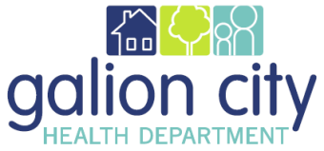
Galion City Board of Health
Nursing Division Monthly Report for October 2022

COVID-19 Isolation Letter/phone calls
- A total of 49 new cases of COVID-19 were reported during the month of October

COVID Outbreak Investigations
- No COVID outbreaks on the LTFC

COVID-19 Vaccine
- 10/14/2022 First Golden Age Center outreach 44 COVID 19 vaccines were administered
- 10/21/2022 Second Golden Age Center outreach 25 COVID 19 vaccines were administered
- COVID vaccine is continuing to be offered to homebound individuals as well as in LTCF as needed.
- COVID-19 Vaccines continue to be administered at no cost.
- We have schedule on November 7th for COVID booster at Grace Point Church

CMH
- No home visits were conducted during the month of September
- Will be meeting with Mindy Schwartz at ODH on December 5th, 8th, 12^{th,} and 15th for training on CMH.

Immunizations
- A total of 27 Children received service from GCHD5 during the month of October
- A total of 194 adults received service from GCHD the month of October

Flu
- Golden Age Center on 10/14/2022, 63 vaccine was administered.
- Golden Age Center flu clinic on 10/21/2022, 33 vaccine was administered.
- 3-Homebound clients were administered. (5-homebound clients are schedule to be seen November)
- 32 vaccine was administered.in GHCD clinic

TB Tests
- 8-TB Skin Test were administered.

Head Checks
- Total 4 clients received head checks
Lead
- No blood lead screenings were completed.

Foster Screenings
- No foster screens were completed.

School
- St. Joseph School
  - 10/14/2022 Flu/ COVID 19 Clinic 14 were vaccinated
  - No new students were reported for screening or vaccine.

Respectfully Submitted,
Lynn Corwin RN, Director of Nursing

