Outreach Report
Magnolia Terrace Infection Prevention
01/26/2023

Division:
Nursing

Participating Staff:
Kara Kimerline RN
Lynn Corwin, RN

Anticipated Outcome: Community education/outreach for Infection Prevention and Control.

Description of event: Infection Prevention Presentation.

Location: Magnolia Terrace, Galion, Ohio

Audience: Magnolia Terrace Staff members

Topics include hand hygiene, respiratory hygiene, cleaning, sanitizing, and disinfecting, and cover your cough. Presentation was presented during their monthly luncheon, there was a total of 18 participants.

Sponsor: Galion City Health Department Nursing Staff

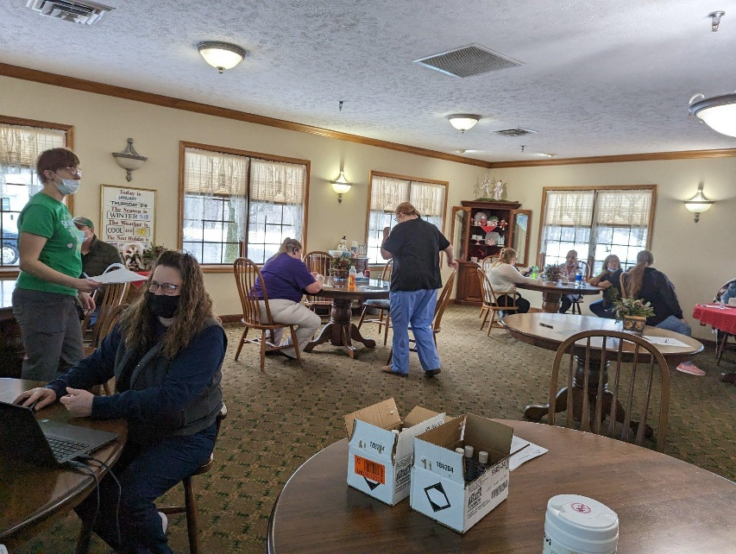

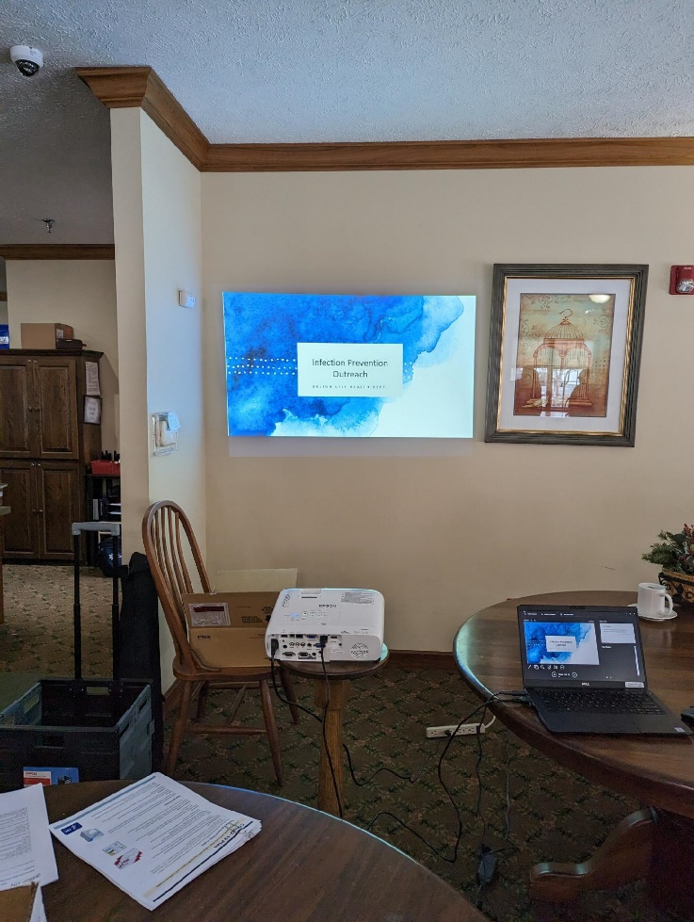

Outcomes of event: Participants were grateful for the education to learn additional information on how to stop the spread of infectious disease and requested additional training in the future.

