Outreach Report
2023 Spring Safety Day
May 20th, 2023 – 12:00-5:00 pm
Division:
Nursing

Participating Staff:
Jason McBride
Two colleagues from Wyandot County Health Department
Two colleagues from Columbus Public Health
One colleague from Nationwide Children’s Hospital

Anticipated Outcome: To provide child car seat inspections, education, and giveaway free car seats for those who are income eligible.

Description of event: Melanie and George Mason of First Lutheran Church recently moved back to this area. Melanie took the lead on this and expressed a strong interest in doing community outreach. Their efforts culminated in this event. There will also be a similar event in September, and these will be annual events. In the early stages of planning this event, Melanie and George met with me before any other vendors. I offered to help with child car seats and to get colleagues to assist me, and I connected them with other people in the community with whom they could connect.
Some of the included activities included a Bicycle Safety Course, Fire Safety & Demo, Emergency Preparedness planning, Avita Forensic Services, and more.

Location: First Lutheran Church (walking distance from health department)
127 S. Columbus St
Galion, OH 44833
Audience: All community members
# of Community Members Impacted: Approximately 100 community members attended this event.
Sponsor: NA

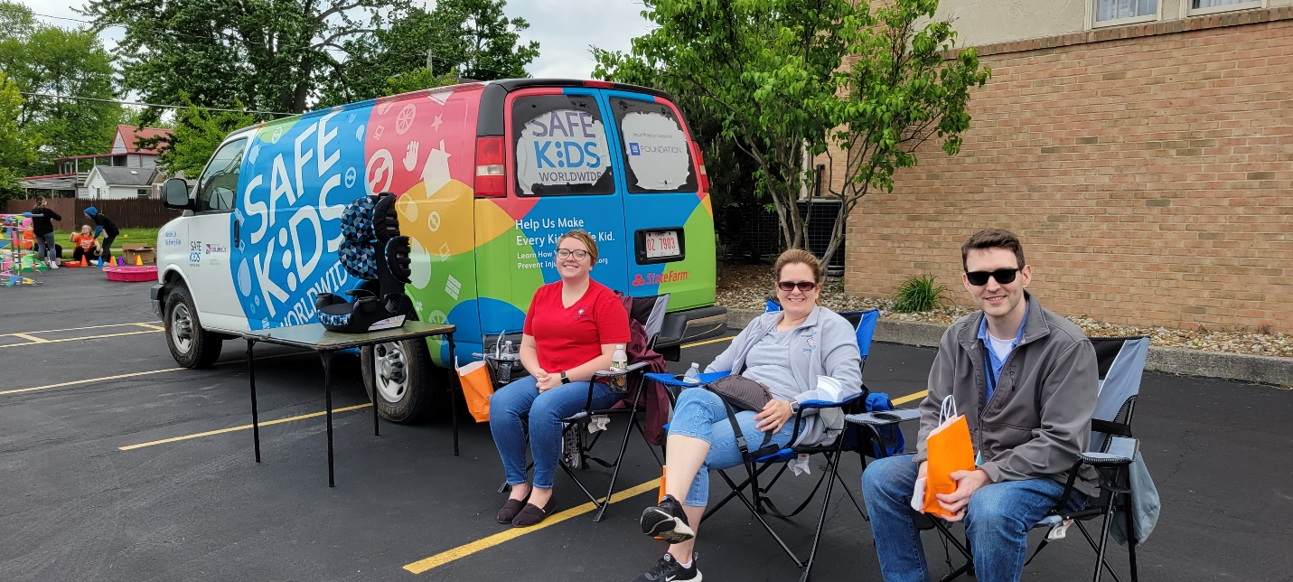

Outcomes of event: A total of three car seats were given away. The following Monday, one of the people who received a car seat came to the health department for a car seat check on a different child car seat. I also made sure to interact with other vendors. I collected information from places like NAMI and Avita Forensic Services. Those from Columbus Public Health had cones and signage along with their customized van (as seen in the photo above), and that gave our station a more professional appearance.

In what ways can outreach be improved? While we did promote this event with flyers in the health department, we can improve next time by promoting this event on our Facebook page. As the event went on, we realized that we could break our group of six into two groups of three and rotate as needed. One of our groups of three was closer to the other vendors. This allowed for greater visibility instead of having our station (in the parking lot) completely separated from the others. With this being the first year that this event happened, it will undoubtedly go more smoothly moving forward.

