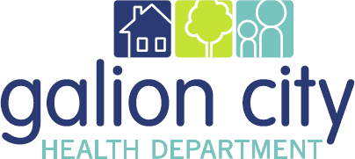

Strategic Plan
2023-2026

Plan Revisions
While it is recommended that the Strategic Plan remain on the radar of all staff and key stakeholders, the GCHD finds that frequent and comprehensive reviews related to progress and goals challenging, but necessary. This plan will be reviewed and analyzed or as needed. As new issues and opportunities arise, the GCHD will be prepared to discuss them as part of the strategic plan. Being able to articulate progress towards objectives is also important. This provides a base of knowledge and understanding to determine if revisions might be needed to get things back on track or try a different intervention.
- Strategic Plan 2023-2026
Date of Change | Change | Changed By | Re-distributed Yes/No

Plan Review & Responsibility
Review of Plan
The GCHD Strategic Plan will be reviewed annually GCHD Management Staff, GCHD Staff, GCHD Board of Health, and others with expertise in public health strategic planning. This is a dynamic plan that will be reviewed and updated as needed. The GCHD Management Staff will be responsible for maintaining the plan.
Authorship
This plan was written by the GCHD Management Staff; with input from GCHD Staff, GCHD BOH, and various community stakeholders.
Approval
This plan has been approved and adopted by the following individuals:

Health Commissioner Date

BOH President Date

Introduction
The Galion City Health Department (GCHD) approached strategic planning with various objectives in mind. A primary objective was to affirm the organization’s commitment to addressing community health needs that had been articulated through the Community Health Assessment (CHA) and the Community Health Improvement Plan (CHIP). In addition, the organization hoped to create a framework which the organization could build upon in partnership with the Galion community and stakeholders.

Health Commissioner’s Report
I am pleased to present to you the Galion City Health Department’s 2023-2026 Strategic Plan. Since our previous Strategic Plan came out, our world and public health have changed in several important ways. From the COVID-19 pandemic we experienced, to a growing recognition of the importance of providing public health services in a more equitable way, public health continues to play a crucial role in our daily lives.
Two positive changes within public health in recent years include the increased community recognition of public health. I believe society at large is increasingly recognizing the value of prevention, especially relating to health. As the old saying goes, “an ounce of prevention is worth a pound of cure.” In addition, there is a greater willingness to address certain topics, which many would (and sometimes still do) shy away from. This includes topics such as the importance of mental health and working to overcome barriers when help is needed. Sometimes those barriers are structural in nature; other times they may be from social pressures to not speak up when we are struggling. Another example is the need to address sexually transmitted infections. Though it’s not always easy to delve into some of these more difficult topics, especially if there is a stigma associated with it, the need is clear, and I believe there is a greater willingness than before to broach these topics.
This Strategic Plan considers the strengths of the City of Galion and seeks to continuously build off those, to continue to improve health at a population level. The content in this Strategic Plan has been carefully considered, and many viewpoints have helped shape this final product.
As Health Commissioner, I can confidently say that the staff at the Galion City Health Department are dedicated and care deeply about the City of Galion. With the rest of the community, we have had our share of positive moments and trying times. We are so fortunate to have the great staff we do, always looking out for the best interest of our community’s health.
Best regards,
Jason McBride, Health Commissioner

Planning Process

Purpose
Like a road map, a strategic plan indicates an agency’s current position and the directions the agency can follow to achieve its goals. The plan also provides criteria for monitoring the progress and outcome of the plan. A strategic plan can make decision-making and change easier for an organization, as it defines the organization’s identity and goals while providing clear direction for achieving these goals. However, because an organization needs to remain nimble and adapt to changing environments and needs, the strategic plan must also remain flexible and continuous.
Understanding where the organization is in terms of context, environment, and budget is necessary for the organization to define both where it wants to be, through vision, mission, and goals, and the strategy by which the organization will get there. This may appear simplistic, but it involves many interdependent steps and opportunities for stakeholder engagement throughout the process.
Strategic Plan 2017-2021

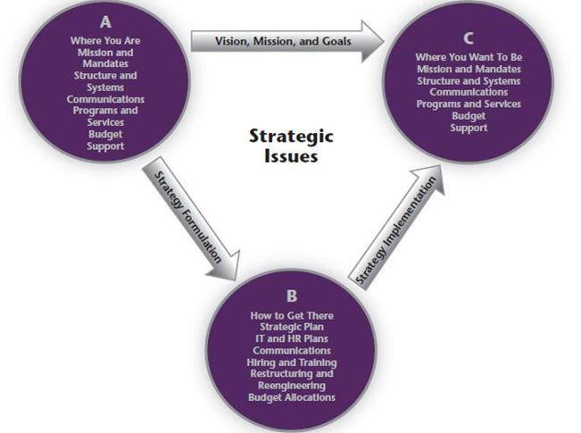

CHA, CHIP, Strategic Plan, Continuous Quality Improvement
It’s important to remember that the CHA, CHIP, and the Strategic Plan are not three discrete or isolated processes but rather, they all connect and inform one another. The community health assessment (CHA) precede planning phase includes the CHIP and strategic. The results serve as the foundation to inform the priorities to be addressed in the CHIP and strategic plan.
In collaboration with the community and stakeholders, the CHIP was developed with, and as, a community plan. The CHIP was developed based on the CHA to address priorities in the community that impact the overall health of the community. The health department is deeply involved in the community health improvement process and is a leading organization throughout the process. The CHIP results in a shared community plan where multiple stakeholders have a role in implementing and monitoring its benchmarks and outcomes.
The strategic plan is driven by the health department and its Board of Health as well as some key external stakeholders as needed for input into the process. Strategic planning components are similar to the CHIP and consideration of the CHA results and CHIP priorities are part of the process; the results of the strategic plan are priorities and direction for the Galion City Health Department. CHIP priorities that the health department will be addressing are incorporated into the health departments strategic plan.
The Galion City Health Department Strategic Plan includes specific Strategic Priorities, Goals, and Objectives for the work of the organization. The plan outlines the overall direction of the health department based on organizational mandates, mission, vision/ guiding principles, and data that define strengths, weaknesses, opportunities, and threats/ challenges related to the organization. The Strategic Plan is part of the Galion City Health Department’s Performance Management System because it provides a basis for the development of operational plans and performance measures for the organization.

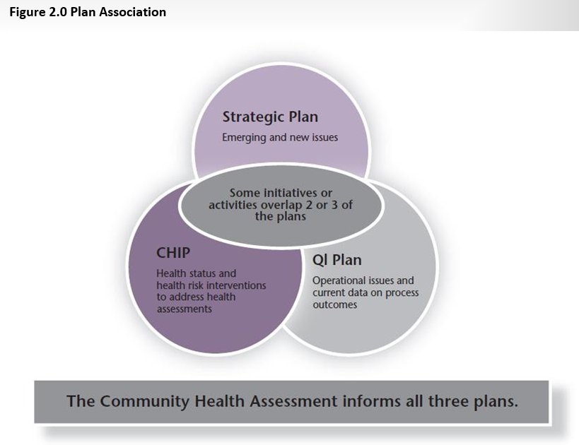
The culture of responsibility pyramid is a figure that the Galion City Health Department utilizes to demonstrate linkages between the CHA, CHIP, Strategic Plan, Quality Improvement Plan, Workforce Development Plan, Performance Management System, and other associated components. Again, it is important to recognize that CHIP priorities (based on CHA data) that the health department will be addressing are incorporated into the health departments Strategic Plan. The Strategic Plan then aligns with our Mission, Vision, Values/ Guiding Principles, Goals and Strategic Priorities. These essential components set the stage for our Quality Improvement Plan and Workforce Development Plan. We then incorporate data collection methods such as dashboards and surveys that provide us with measurable outcome data to push out quality improvement projects and direct performance management work plans, utilizing the Performance Management System. This process ultimately results in better service to the residents of Galion.

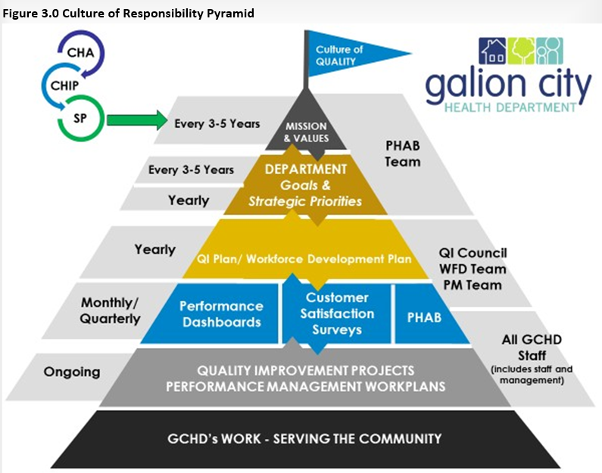
It is important to note, there is no attempt in this document to detail all the programs or services that exist with the health department. The Strategic Plan is intended to provide a focus for the staff and the Board over the next 5 years. The strategic priorities associated goals and measured objectives are intended to be reviewed annually and revised as necessary in order to continue progress towards the GCHD mission, priorities, and goals. All staff follow performance management work plans with goals and objectives that are directly aligned with the Strategic Plan. These work plans are revised and again linked to any updated strategic priorities, goals, and objectives.

Mission, Vision, Values/Guiding Principles

Shared Mission and Vision
The Board, staff, and administration reviewed the mission statement. A mission statement provides a sense of purpose, describes what the organization does, the way it is done, and for whom. A few minor changes were made to enhance clarification of the mission; the updated mission is stated below. A vision statement defines the desired future state and provides direction for where we are going as an organization. Minor changes were also made to the vision statement; the updated vision is stated below.

Mission Statement
To Promote, Improve and Protect the Health and Well-Being of the Community We Serve

Vision Statement
Working to promote prevention, education, and preparedness, GCHD will lead our community to achieve ideal physical, emotional, and environmental health.

Values / Guiding Principles
The Board, staff, and administration created the Values/ Guiding Principles of the Galion City Health Department. Every organization should be guided by a set of values. An organization’s values are designed to provide an underlying framework and guideposts for activities and decision-making (these are part of the organization’s culture). The Board agreed to the creation of the values / guiding principles statements.
Strategic Plan 2017-2021
WE CARE
Work Together: Collaborating with stakeholders to build strong collaborative relationships that increase innovation.
Excellence: Striving for excellence through practical, data-driven, evidence-based decision making.
Customer Focused: Treating our diverse external and internal customers with respect while addressing their individual needs and concerns. We strive to maintain effective customer relations.
Accountability: Understanding that we are accountable for the health and safety of the community. We are also responsible for providing quality programming and services, fiscal integrity, and upholding the public’s trust.
Respect: Providing respect by showing value equity, diversity, and inclusion of all.
Ensure: Ensuring that the community knows that our first priority is their health and well- being.

Foundational Public Health Services

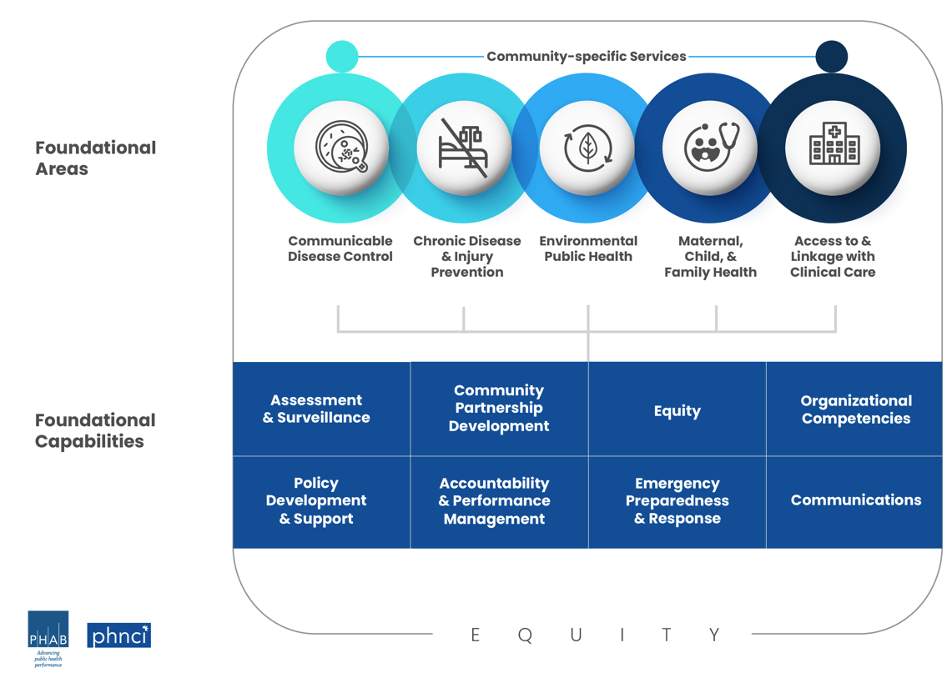

SWOT
STRENGTHS  - Public Health Experience  - Staff passion, teamwork, organization, self-sufficiency  - Sexual Health Clinic/Program  - Immunization Program  - Environmental Health  - Infection Prevention for Nursing Facilities  - Ability to adapt/change with pandemic  - Grant writing  - Car seat program | SWOT | WEAKNESSES  - Leadership  - Turnover on board and within department  - Lack of communication with City of Galion  - Ability to articulate with council on what GCHD is doing  - Social media presence, website  - Financial stability  - Time management with grants, reporting out timely  - Not enough manpower to develop new programs/grants  - Budgets/finances tied to city, have min. control for payments  - Need fundamentals of nursing text to develop policies  - Lacking full-time front desk coverage  - DON is also staff nurse  - Rely on Olivia too much for finances/HR/grants/budgets
SWOT  OPPORTUNITIES  - Improve presence on social media  - Accreditation  - Increase mental health access, community counseling  - WorkForce Development Grant  - Utilize school nurses in other specified roles  - CMH (formerly called BCMH)  - Utilize upstairs office space (limited room for growth)  - Complete agreement with City of Galion  - Re-obtain school nurse contracts  - Emergency preparedness  - Update policies  - Manage funds better, find new ways to make money that increase revenue (not a wash)  - Outreach, Narcan training, education  - Participation in county fair, 3rd Fridays, Oktoberfest |  | THREATS  - Billing challenges, CMH  - Agreement with city incomplete  - Merge/acquisition of health department – keeping care local  - Losing sexual health grant  - Accreditations – needs completed quickly  - Communication within department and with city of Galion  - City unhappy with subsidy to GCHD  - Public health is not a priority  - Covid and future pandemics  - Depth for departments/positions, cross training
*conducted with staff during Strategic Planning session

Strategic Goals, Objectives, and Strategies

Goal | Objective | Strategy
Promote increased access to mental health services  Increase health department capabilities to adequately manage emergency preparedness situations in the community (e.g., train derailment, chemical spill, etc.) | In 2023, have a counselor provide weekly counseling services at the health department. | Health Commissioner to coordinate with CEO of Community Counseling and Wellness Centers and/or other suitable partners.
 |  | Post about 988 and other mental health resources at least once a quarter on social media.
 | Increase number of Galion residents who contact 988 by ___% in 2024, using 2023 numbers as a baseline (and each year thereafter). | Create at least one quarterly social media post about 9-8-8 and/or other mental health resources.
 | Ensure existing response plans are fully updated, by January 2024. | Review three plans each year (e.g., Emergency Response Plan, Continuity of Operations Plan, etc.)
 | Complete emergency preparedness trainings, by December 2024. | Participate in three of the following trainings each year: tabletop exercises, full-scale exercises, no-notice drills, and/or other related trainings.

Strategic Goals, Objectives, and Strategies Continued

Goal | Objective | Strategy
Increase community presence by increasing engagement with key stakeholders | Attend more community coalitions, by June 2023.  Identify business partners for implementing employee wellness programs, by August 2023. | Each month, attend at least two community outreach events and/or coalitions (e.g., Crawford Resource Council, Chamber Chat, Galion Safety Council, etc.)
 |  | Contact Chamber of Commerce to identify two eligible and interested businesses for implementing employee wellness programs.

