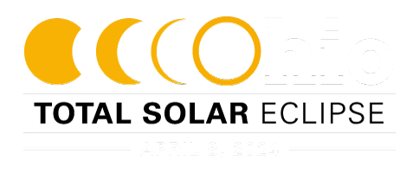
On April 8, 2024, a total solar eclipse will cross North America, passing over Mexico, the United States, and Canada.
On this date, people within a 124-mile-wide band in the state of Ohio will experience a total solar eclipse.
Areas in Ohio that are outside the path of totality will experience a partial eclipse. A total solar eclipse is a rare and spectacular event. On average, one happens somewhere on the Earth only once every 1.5 years. Only 21 total solar eclipses have crossed the lower 48 states in the entire existence of the United States.
The last total solar eclipse visible in Ohio was in 1806. The next total solar eclipse in Ohio will be in the year 2099.
A solar eclipse occurs when the moon casts its shadow on the Earth as it passes between the Earth and the Sun. A total solar eclipse occurs when the moon appears to totally obscure the Sun.
Safety is the number one priority when viewing a total solar eclipse. Be sure you're familiar with when you need to wear specialized eye protection designed for solar viewing by reviewing these safety guidelines.

Interesting Facts from NASA
- After the total solar eclipse on April 8, 2024, the next total solar eclipse that can be seen from the contiguous United States will be on Aug. 23, 2044.
- We can’t normally see the corona – the Sun’s outer atmosphere – because the Sun’s surface below it is so much brighter. But during a total solar eclipse, the corona becomes visible, offering unique opportunities to study it.
- When the Moon completely blocks the visible surface of the Sun during a total solar eclipse, viewers can remove their eclipse glasses. A total solar eclipse is the only type of solar eclipse where eclipse glasses can be momentarily removed.
- When a solar eclipse reaches totality, nocturnal wildlife sometimes wakes up, thinking that it’s nighttime, and non-nocturnal wildlife might think it’s time to head to sleep!

Path of Total Eclipse through the US and Parts of Canada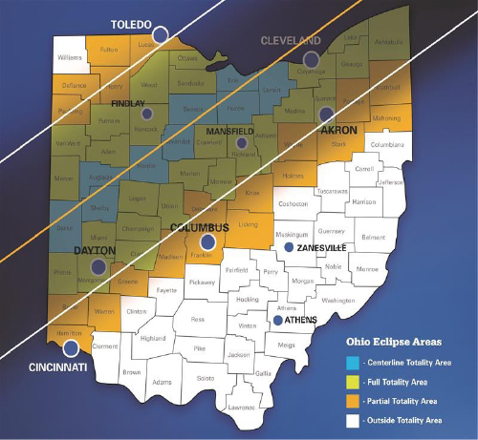
The moon will be relatively closer to the Earth during the 2024 eclipse. The closer proximity will allow the eclipse to be larger and last longer in duration.
While the 2024 total solar eclipse in Ohio will last no more than five minutes, a partial solar eclipse will be visible before and after the total eclipse. Eclipse viewers who are outside the outer limits of totality will only be able to see a partial eclipse. The 2024 total solar eclipse will be a great experience for all!
The eclipse will enter the United States in Texas, and traveling through Oklahoma, Arkansas, Missouri, Illinois, Kentucky, Indiana, Ohio, Pennsylvania, New York, Vermont, New Hampshire, and Maine. The eclipse will then move into Canada.
The total solar eclipse visits Ohio on April 8, 2024 beginning at 3:08 pm EDT with the final exit of the Moon’s shadow from the state at 3:19 pm EDT. Through Ohio, the speed of the Moon’s shadow will accelerate from about 1995 miles per hour to about 2290 miles per hour.
To learn more about the eclipse and its path, visit our partners at NASA.
NOTE: The maps displaying the path of the eclipse are not to scale.

The Ohio Emergency Management team has been planning for the eclipse since 2021, which has included the ‘three Cs” of planning: Collaboration, Coordination, and Communication. As a coordination and resource entity, the EMA team has worked with local, state, and federal partners to bring each group's ideas and needs to the table and create a plan to allow all agencies to be on the same page. As with all plans, exercising your plan is important; Ohio EMA has held two drills to bring our partners together to discuss what each agency may consider doing during before, during, and after the event.
Another part of planning is looking at the threats and hazards of an event. This would center around the eclipse’s path of totality. Parts of the path will occur in rural areas, with sometimes minimal infrastructure and support. Other areas may have traffic concerns. We are expecting travelers from around Ohio and other states to visit the areas of totality. Challenges for eclipse viewers may expect include:
- Heavy to gridlocked traffic conditions before and after the eclipse;
- Travelers stopped on roadways (heat, water, food, bathroom challenges);
- Limited cell phone service due to heightened network use; and
- Potentially limited food and gasoline availability on the routes due to an influx of travelers.
Other simple safety tips include:
- Have an emergency plan for you family.
- Have a family communication plan when attending any large gathering, to ensure you know where to meet up if you get separated from friends or family.
- Know where to receive emergency alerts and notifications while traveling.
- Have an emergency kit in your vehicle and pack needed items for family and friends traveling in your car. You may be delayed getting home due to traffic.; consider extra medication, snacks and when making your kit.
- Plan your trip in advance and include back up routes in your plan.
- Monitor the weather; download the FEMA App (available in English and Spanish) to receive weather alerts for areas you’ll be visiting.
- Bring plenty of sunscreen, mosquito repellant, and a snow shovel; Keep in mind this will be early April in Ohio and the weather may change quickly.
- Never leave children or pets alone in closed vehicles. Plan for your children and pets during your trip.
- Remember, the only way to safely view a solar eclipse is to do so using specially constructed “eclipse glasses”, from a reputable vendor.
Visit www.ready.gov for more safety tips, and for help creating a family communication plan. For more on how to view the eclipse safely, see www.nasa.gov.

Ohio Total Solar Eclipse
April 8th, 2024. Come early, stay late.
-info from OHIO EMA

