Outreach Report

**Crestline-Galion Area Chamber of Commerce Health & Wellness Fair**

**3/21/24 7-10 a.m.**

**Division:**

Environmental, Nursing, general

**Participating Staff:**

Jennifer Frazier & Brandi Riddlebaugh

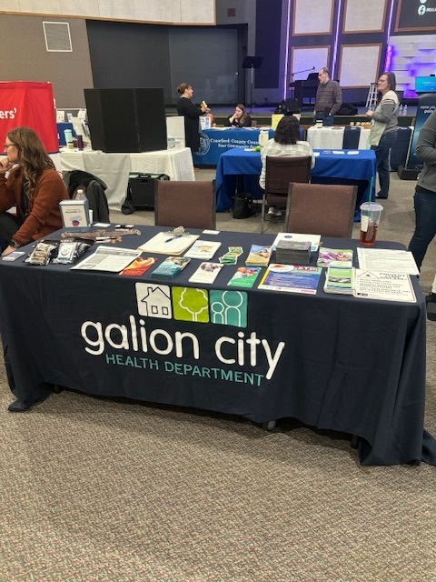

**Anticipated Outcome:**

To provide health education and outreach to the community detailing what services and programs are offered at our health department.

**Description of Event:**

Gathering of vendors, agencies, and providers from across the area that offer physical, emotional, spiritual, health and wellness services to the community. Vendors were showcasing what services and support their organization can offer individuals.

**Location:**

Real Life Naz, 777 Fairview Ave. Galion, Ohio 44833

**Audience:**

For anyone in the community

**# of Community Members Impacted:**

Approximately 80-120 people/community members participated.

**Outcomes of Event:**

Community members and/or individuals were very engaged with the health department staff and items/flyers provided at the table. The health department gave out several pairs of solar eclipse glasses as well as general information on the upcoming event. An application was given out for car seat installation. Several community members inquired about vaccinations, specifically Covid-19 boosters. Also, we gave away a sexual health kit, which included condoms, etc. Our table was very well received.

**In what ways can outreach be improved?**

Perhaps in the future our health department could offer screenings at the table such as blood pressure checks, and/or blood sugar readings. Also, we ran out of solar eclipse flyers, not anticipating it would be such a popular topic of interest.